**NITTE MEENAKSHI INSTITUTE OF TECHNOLOGY**

(AN AUTONOMOUS INSTITUTION, AFFILIATED TO VISVESVARAYA TECHNOLOGICAL UNIVERSITY,

BELGAUM, APPROVED BY AICTE & GOVT.OF KARNATAKA)

**WEB APPLICATION DEVELOPMENT**

**on**

**TIMBER YARD MANAGEMENT SYSTEM**

Submitted in partial fulfilment of the requirement for the award of Degree of

Bachelor of Engineering

in

Computer Science and Engineering

Submitted by:

Kanaad D S 1NT19CS092

Chinmay Ganapati Hegde 1NT19CS059

**Under the Guidance of**

**Dr . Uma P**

**Assistant Professor, Dept. of CSE, NMIT**

Department of Computer Science and Engineering

**(Accredited by NBA Tier-1)**

**2020-2021**

**NITTE MEENAKSHI INSTITUTE OF TECHNOLOGY**

(AN AUTONOMOUS INSTITUTION, AFFILIATED TO VISVESVARAYA TECHNOLOGICAL UNIVERSITY,

BELGAUM, APPROVED BY AICTE & GOVT.OF KARNATAKA)

Department of Computer Science and Engineering

**(Accredited by NBA Tier-1)**

This is to certify that the Phase II Report on “**TIMBER YARD MANAGEMENT SYSTEM**” is an authentic work carried out by **Kanaad D S (1NT19CS092), Chinmay Ganapati Hegde (1NT19CS059)**students of **Nitte Meenakshi Institute of Technology**, Bangalore in partial fulfilment for the award of the degree of **Bachelor of Engineering** in COMPUTER SCIENCE AND ENGINEERING of Visvesvaraya Technological University, Belagavi during the academic year 2020-2021. It is certified that all corrections and suggestions indicated during the internal assessment has been incorporated in the report.

**Internal Guide HOD**

Dr . Uma P Dr . Thippeswamy M. N

Assistant Professor, CSE Professor , HOD , CSE

NMIT Bangalore NMIT Bangalore

**ACKNOWLEDGEMENT**

The satisfaction and euphoria that accompany the successful completion of any task would be incomplete without the mention of the people who made it possible, whose constant guidance and encouragement crowned our effort with success. I express my sincere gratitude to our Principal **Dr. H. C. Nagaraj**, Nitte Meenakshi Institute of Technology for providing facilities.

|  |  |  |
| --- | --- | --- |
| **NAME** | **USN** | **SIGNATURE** |
| Kanaad D S | 1NT19CS092 |  |
| Chinmay Ganapati Hegde | 1NT19CS059 |  |
|  |  |  |

We wish to thank our HOD, **Dr.Thippeswamy M.N.** for the excellent environment created to further educational growth in our college. We also thank him for the invaluable guidance provided which has helped in the creation of a better project.

I hereby like to thank our ***Dr . Uma P, Assistant Professor***, Department of Computer Science & Engineering on her periodic inspection, time to time evaluation of the project and help to bring the project to the present form.

Thanks to our Departmental Project coordinators. We also thank all our friends, teaching and nonteaching staff at NMIT, Bangalore, for all the direct and indirect help provided in the completion of the project.

**Date: 22/07/2021**

**TABLE OF CONTENTS**

**CHAPTER 1: INTRODUCTION**

1.1 PROJECT OVERVIEW

1.2 PROJECT DESCRIPTION

1.3 OBJECTIVES

**CHAPTER 2: SYSTEM REQUIREMENTS AND SPECIFICATIONS**

2.1 HARDWARE REQUIREMENTS

2.2 SOFTWARE REQUIREMENTS

**CHAPTER 3: DESIGN**

**CHAPTER 4: IMPLEMENTATION**

**CHAPTER 5: CONCLUSION**

**REFERENCES**

**CHAPTER 1**

**INTRODUCTION**

1.1 **PROJECT OVERVIEW**

Timber Yard management system contains the details about the orders placed by customers for their domestic or commercial type use and the final order records .

**1.2 PROJECT DESCRIPTION**

Till today state govt haven’t come up with a basic timber yard website so keeping this in our mind we developed a Timber Yard management system that stores the details about the orders placed by the consumers of their required qualities of timbers . Consumer is the main charge as he orders the products in amount of pieces from him the complete process starts.

The project is programmed using Web concepts of **HTML, CSS, PHP, JAVASCRIPT, JQUERY, AJAX** .

Database concept is used for storing the process details (in systematic manner) where the complete details of order, consumer, accounts which will be used for future use as more records can be appended.

**1.3 OBJECTIVE**

The development of this system focuses on certain goals. These said purposes are classified and expound as follows: General Objective To make use of the technology through an improved automated record storage of Timber Yard . Thus, minimizing the errors that resulted from the prior systems. It is projected towards the improvement of relationship between the farmers and Consumers .

The project specifically aims:

1)To transmit macro economical signal to Consumer/Dealers.

2)Balancing Demand and Supply.

3)Promoting the efficient use of resources in the production and

distribution systems

4)Permanent Storage of orders and account.

5)To design an system that is simple, user friendly and easy to understand.

**CHAPTER 2**

**SYSTEM REQUIREMENTS AND SPECIFICATIONS**

**SYSTEM REQUIREMENTS**

**3.1 HARDWARE REQUIREMENTS PROCESSOR:**

Intel Core 2

Duo 1.3GHz or Faster.

RAM:512MB or More.

SPACE REQUIRED: 100MB.

**3.2 SOFTWARE REQUIREMENTS**

OS: Windows XP,7,8,8.1,10, Linux, Ubuntu, Mac OS.

**Additional software required:**

Visual studio code, Xampp ,Mysql.

**CHAPTER 3**

**DESIGN**

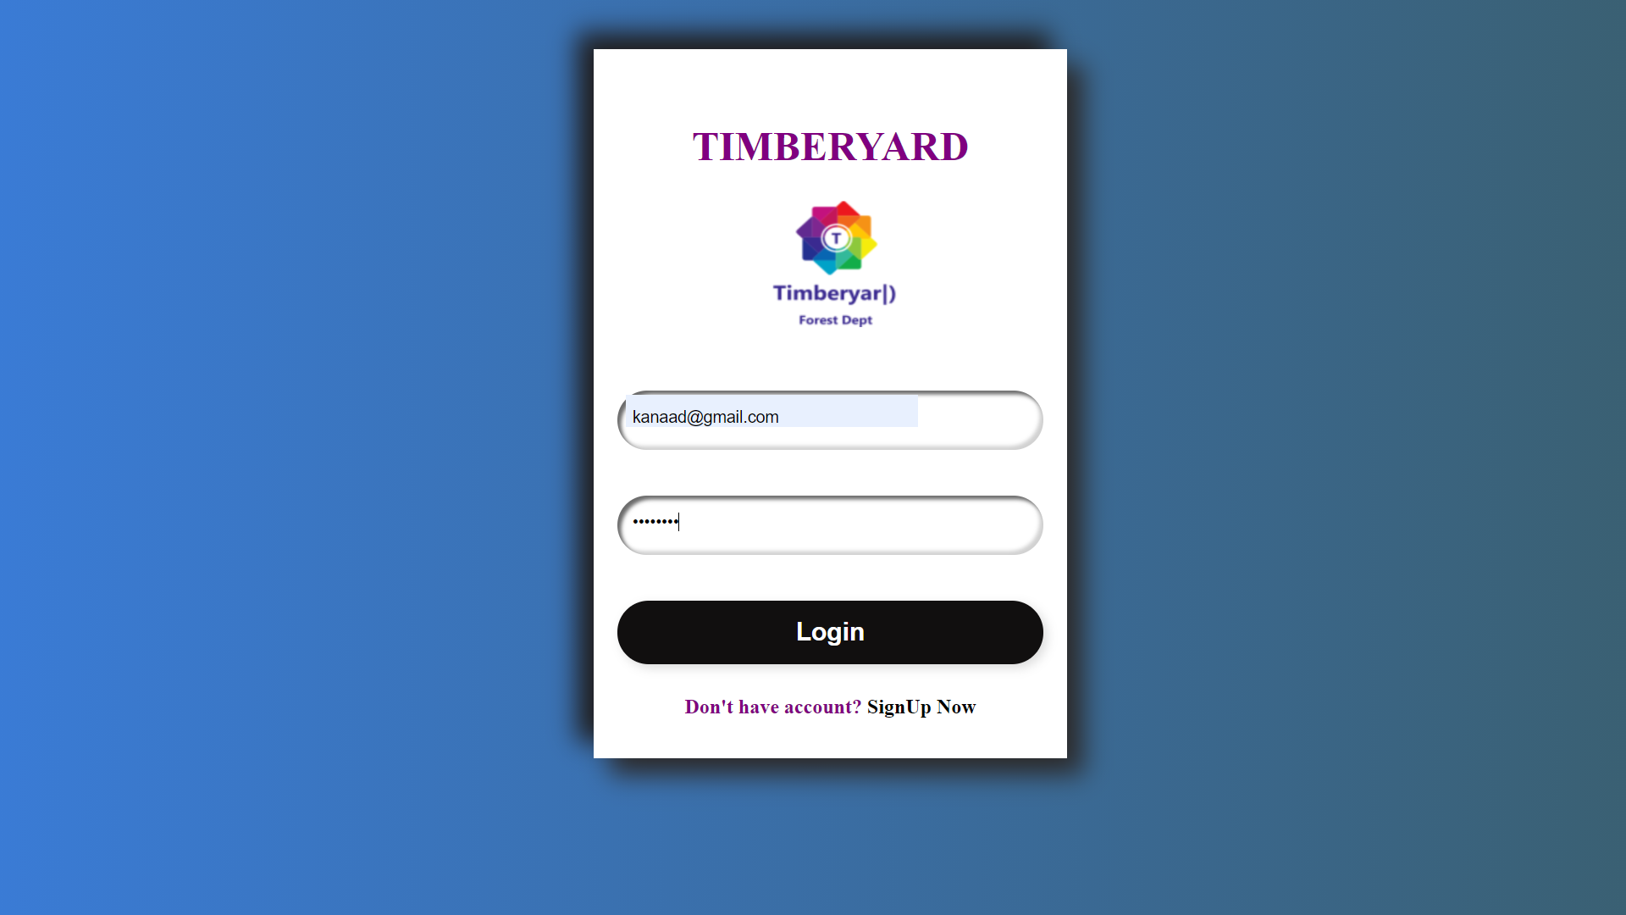

The above is a place where the user will login for the timberyard website if the mail is not registered then will show an alert that user is not yet registered and will redirect to the signup page where the user can sign up initially so that he can have the access to the website through logging in. If the password for the entered email is not matching then it will show an alert of password is wrong and the user has to again enter the valid password for the registered email.

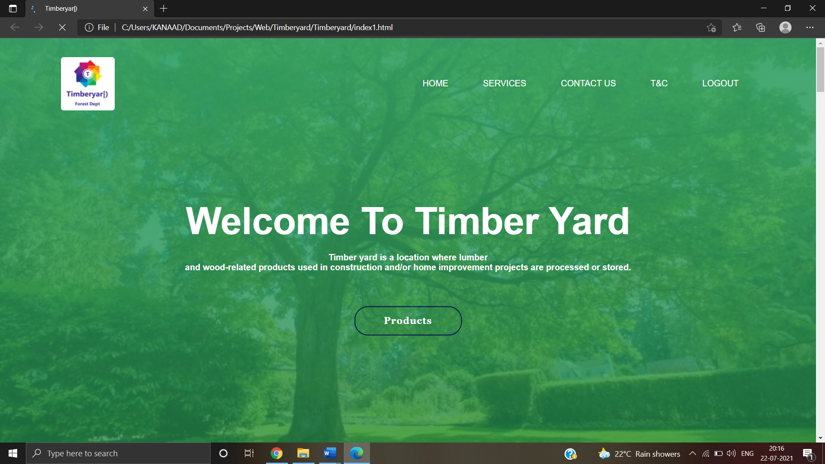

The above figure is the entrance page of the website where it is filled with a Timberyard logo(Created by our team) and buttons of home, services, contact us, T&C and logout.

The basic of many HTML tags have been used and CSS is used for the font, color etc properties designs. When we click on home button it refresh once again that is main Title moves up and down for which we used the Jquery . Then for services it will redirect us to the slides where it contains about the services provided by us ( There we have used the slides options so that after few seconds they slide one after other). Logout to move out of the site as it redirects to login page . Contact us and T&C we move to i.e Instagram, facebook , twitter and terms and conditions part respectively.

When we click on the products button it we direct us to all products details so that we can choose the number of items there then we should click on proceed button to move to the order form

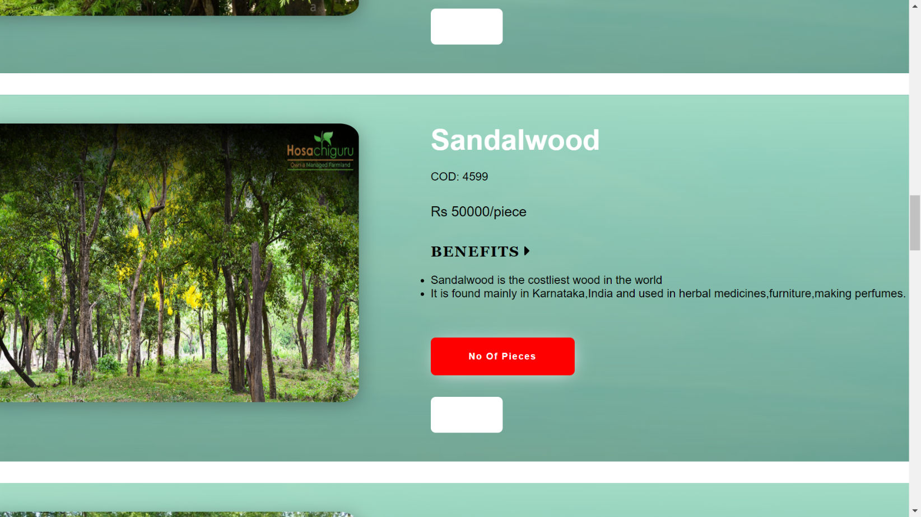

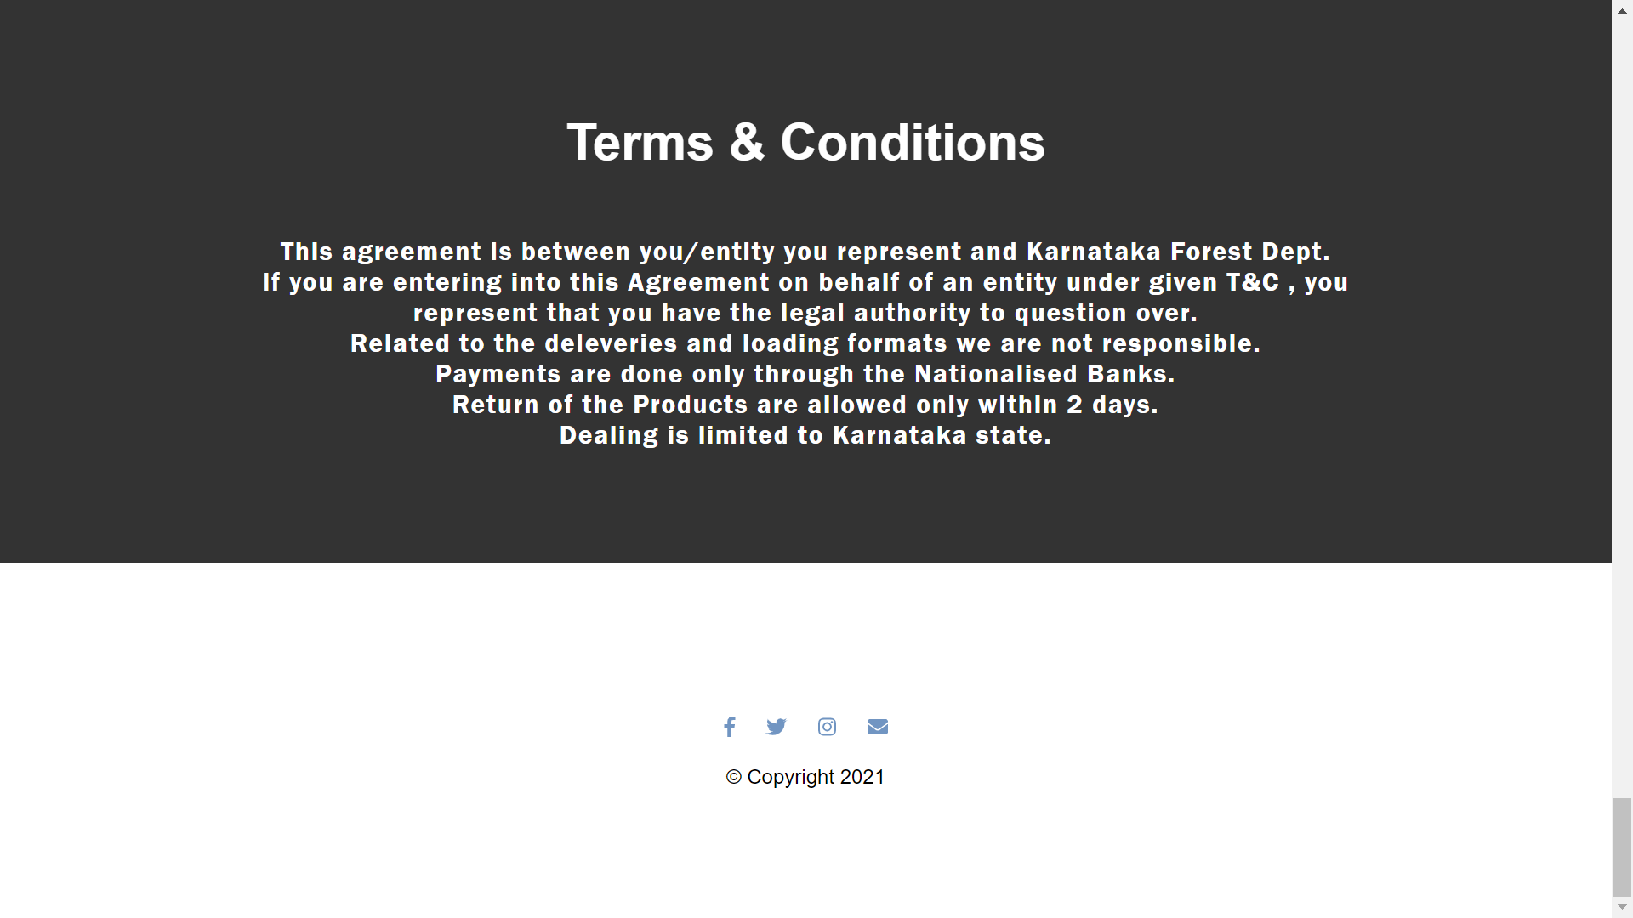

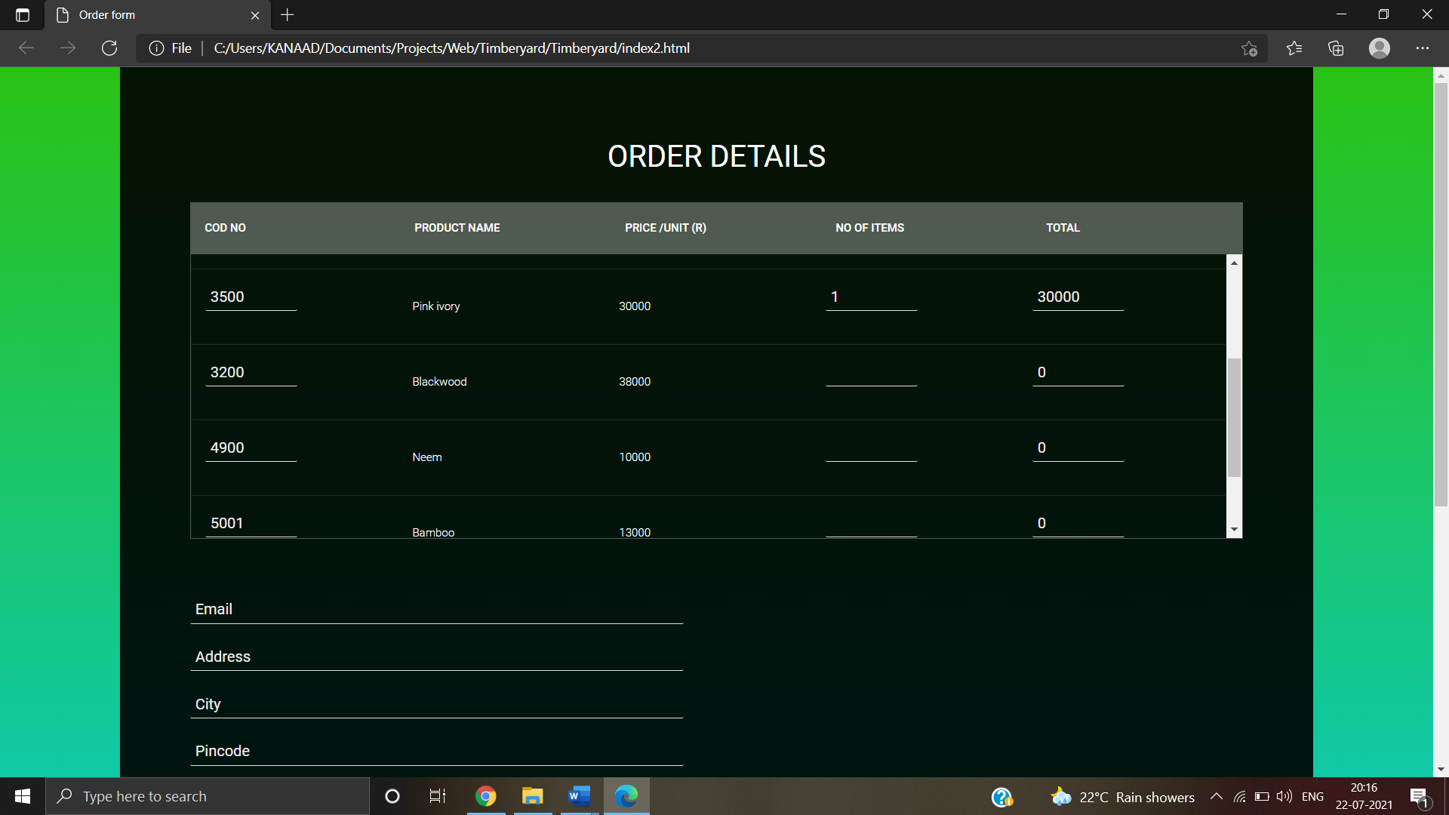

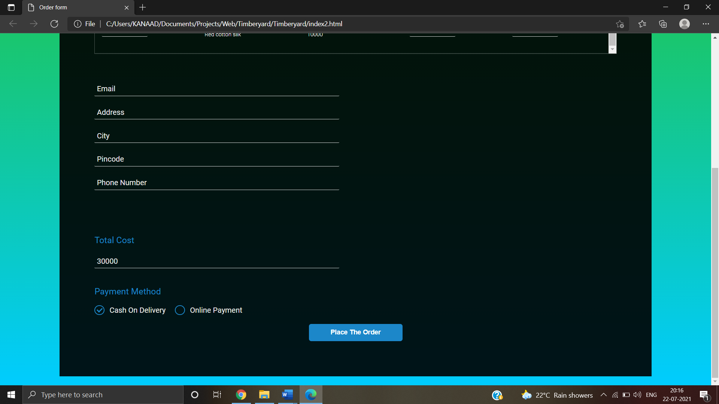

As we click on the proceed button . Here the details of the items selected by the customer will be displayed including the amount how much to paid as to place the order . In this the details of email, address, city, pin code , Phone number ,Total Cost will be displayed as some of them should filled and a option to choose payment method . For email it will be printed early as he signed in before . Here we have used Ajax method that is when we enter the pin code automatically the city will be printed . Then as soon as we click on the place the order button it will give us the message that order is placed successfully if there are no interrupts.

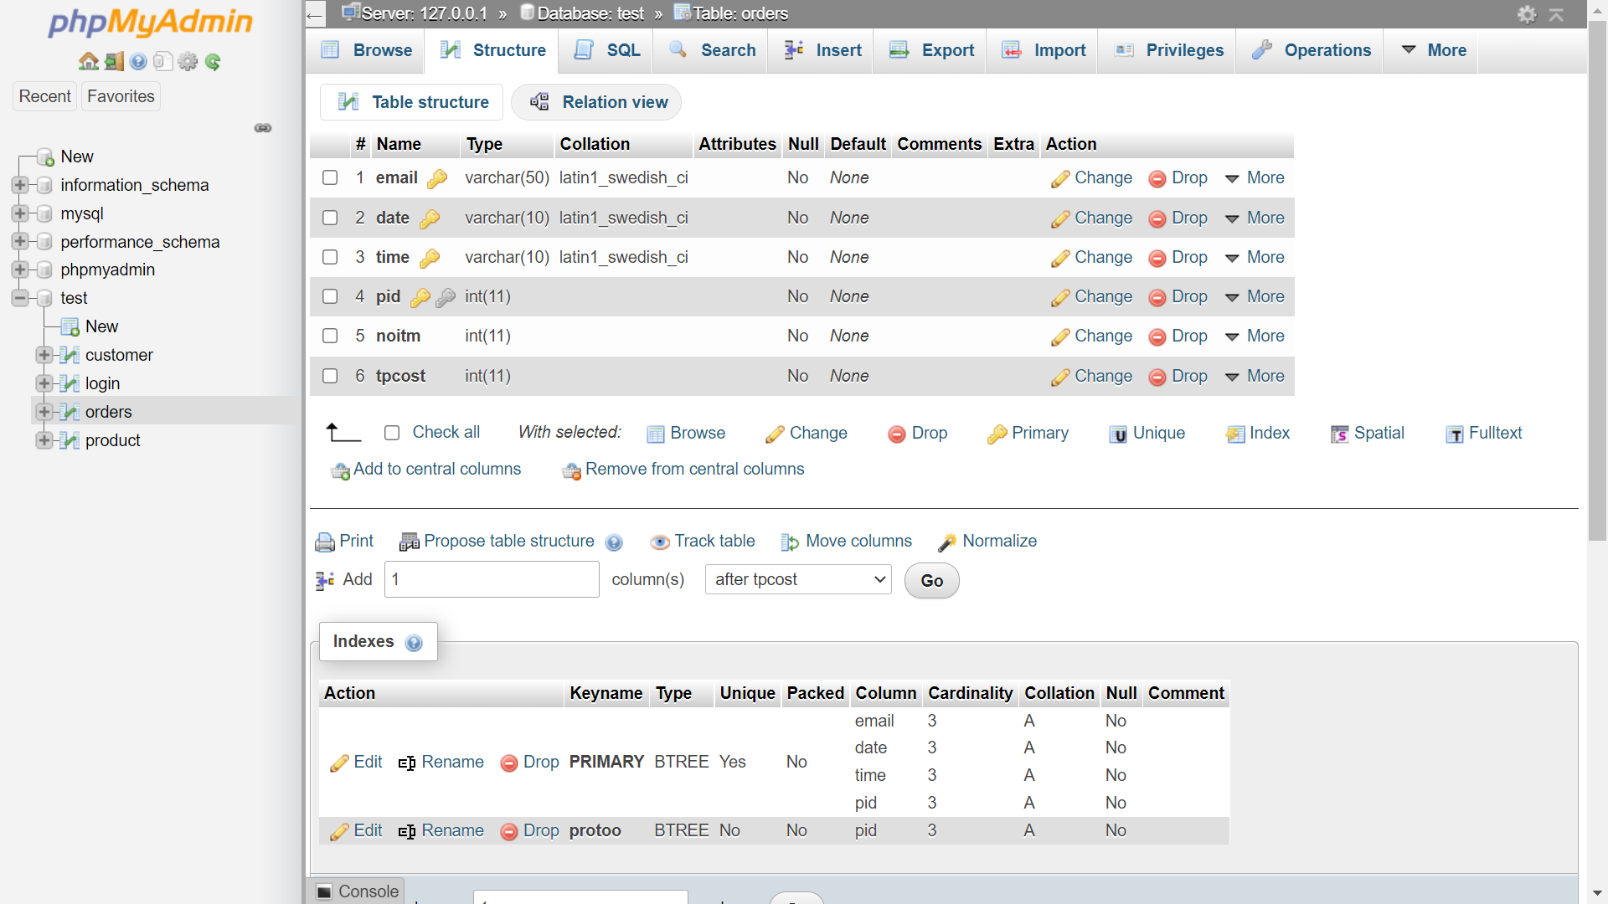

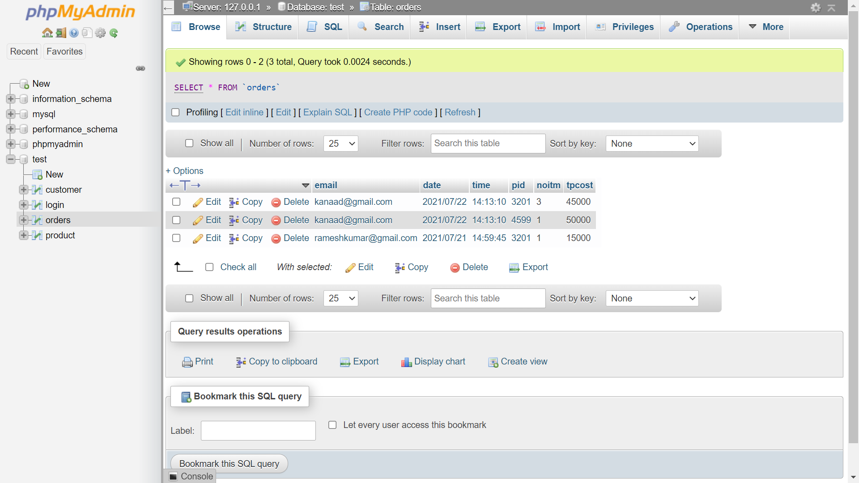

As the order has been placed the details of the order as well as the customer who have ordered the items their details will be stored using mysql. Here we have created the test database where we have created 4 tables namely login ,orders ,customer and product. The login table is used for login verification of the user and for the future use. Orders table is used to store the individual product details of the products ordered by the user. Then customer table is used for storing customer details who have ordered the products. Products table is used for saving product details. The required primary and foreign key is declared as well for each table.

**CHAPTER 4**

**IMPLEMENTATION**

**4.1 HTML:**

**Hyper Text Markup Language** (**HTML**) is a [markup language](https://simple.wikipedia.org/wiki/Markup_language) for creating a [webpage](https://simple.wikipedia.org/wiki/Webpage). In easier words, HTML is a kind of programming language that can make a new webpage. Webpages are usually viewed in a web browser. They can include writing, links, pictures, and even sound and video. HTML is used to mark and describe each of these kinds of content so the web browser can display them correctly. HTML also adds meta information to a webpage. Meta information is usually not shown by web browsers and is data *about* the web page, e.g., the name of the person who created the page.

The basic login, signup, index ,order form are developed using this in the project.

**4.2 CSS:**

**Cascading Style Sheets** (**CSS**) is a [style sheet language](https://en.wikipedia.org/wiki/Style_sheet_language) used for describing the [presentation](https://en.wikipedia.org/wiki/Presentation_semantics) of a document written in a [markup language](https://en.wikipedia.org/wiki/Markup_language) such as [HTML](https://en.wikipedia.org/wiki/HTML).[[1]](https://en.wikipedia.org/wiki/CSS#cite_note-1) CSS is a cornerstone technology of the [World Wide Web](https://en.wikipedia.org/wiki/World_Wide_Web), alongside HTML and [JavaScript](https://en.wikipedia.org/wiki/JavaScript).[[2]](https://en.wikipedia.org/wiki/CSS#cite_note-2)

CSS is designed to enable the separation of presentation and content, including [layout](https://en.wikipedia.org/wiki/Page_layout), [colors](https://en.wikipedia.org/wiki/Color" \o "Color), and [fonts](https://en.wikipedia.org/wiki/Typeface).[[3]](https://en.wikipedia.org/wiki/CSS#cite_note-3) This separation can improve content [accessibility](https://en.wikipedia.org/wiki/Accessibility), provide more flexibility and control in the specification of presentation characteristics, enable multiple [web pages](https://en.wikipedia.org/wiki/Web_page) to share formatting by specifying the relevant CSS in a separate .css file which reduces complexity and repetition in the structural content as well as enabling the .css file to be [cached](https://en.wikipedia.org/wiki/Cache_(computing)) to improve the page load speed between the pages that share the file and its formatting.

Separation of formatting and content also makes it feasible to present the same markup page in different styles for different rendering methods, such as on-screen, in print, by voice (via speech-based browser or [screen reader](https://en.wikipedia.org/wiki/Screen_reader)), and on [Braille-based](https://en.wikipedia.org/wiki/Braille_display) tactile devices. CSS also has rules for alternate formatting if the content is accessed on a [mobile device](https://en.wikipedia.org/wiki/Mobile_device).[[4]](https://en.wikipedia.org/wiki/CSS#cite_note-4)

The name *cascading* comes from the specified priority scheme to determine which style rule applies if more than one rule matches a particular element. This cascading priority scheme is predictable.

In this project same as the HTML we have used CSS in the login,signup,index and order form pages.

**4.3 PHP :**

Php is a [general-purpose](https://en.wikipedia.org/wiki/General-purpose_programming_language) [scripting language](https://en.wikipedia.org/wiki/Scripting_language) geared towards [web development](https://en.wikipedia.org/wiki/Web_development) . The PHP [reference implementation](https://en.wikipedia.org/wiki/Reference_implementation) is now produced by The PHP Group. PHP originally stood for *Personal Home Page*, but it now stands for the [recursive initialism](https://en.wikipedia.org/wiki/Recursive_initialism) *PHP: Hypertext Preprocessor*.

PHP code is usually processed on a [web server](https://en.wikipedia.org/wiki/Web_server) by a PHP [interpreter](https://en.wikipedia.org/wiki/Interpreter_(computing)) implemented as a [module](https://en.wikipedia.org/wiki/Plugin_(computing)), a [daemon](https://en.wikipedia.org/wiki/Daemon_(computing)) or as a [Common Gateway Interface](https://en.wikipedia.org/wiki/Common_Gateway_Interface) (CGI) executable. On a web server, the result of the [interpreted](https://en.wikipedia.org/wiki/Interpreter_(computing)) and executed PHP code – which may be any type of data, such as generated [HTML](https://en.wikipedia.org/wiki/HTML) or [binary](https://en.wikipedia.org/wiki/Binary_number) image data – would form the whole or part of an [HTTP](https://en.wikipedia.org/wiki/Hypertext_Transfer_Protocol) response. Various [web template systems](https://en.wikipedia.org/wiki/Web_template_system), web [content management systems](https://en.wikipedia.org/wiki/Content_management_system), and [web frameworks](https://en.wikipedia.org/wiki/Web_framework) exist which can be employed to orchestrate or facilitate the generation of that response. Additionally, PHP can be used for many programming tasks outside of the web context, such as standalone [graphical applications](https://en.wikipedia.org/wiki/Graphical_user_interface)[[10]](https://en.wikipedia.org/wiki/PHP#cite_note-10) and [robotic](https://en.wikipedia.org/wiki/Robotics) [drone](https://en.wikipedia.org/wiki/Unmanned_aerial_vehicle) control.[[11]](https://en.wikipedia.org/wiki/PHP#cite_note-11) PHP code can also be directly executed from the [command line](https://en.wikipedia.org/wiki/Command-line_interface).

The standard PHP interpreter, powered by the [Zend Engine](https://en.wikipedia.org/wiki/Zend_Engine), is [free software](https://en.wikipedia.org/wiki/Free_software) released under the [PHP License](https://en.wikipedia.org/wiki/PHP_License). PHP has been widely ported and can be deployed on most web servers on almost every [operating system](https://en.wikipedia.org/wiki/Operating_system) and [platform](https://en.wikipedia.org/wiki/Computing_platform), free of charge.

By using Xampp ,we have used this concept to login,signup and store the ordered details ie customer who have ordered .

**4.4 JAVASCRIPT :**

**JavaScript**  often abbreviated as **JS**, is a [programming language](https://en.wikipedia.org/wiki/Programming_language) that conforms to the [ECMAScript](https://en.wikipedia.org/wiki/ECMAScript) specification. JavaScript is [high-level](https://en.wikipedia.org/wiki/High-level_programming_language), often [just-in-time compiled](https://en.wikipedia.org/wiki/Just-in-time_compilation), and [multi-paradigm](https://en.wikipedia.org/wiki/Programming_paradigm). It has [curly-bracket syntax](https://en.wikipedia.org/wiki/List_of_programming_languages_by_type#Curly-bracket_languages), [dynamic typing](https://en.wikipedia.org/wiki/Dynamic_typing), [prototype-based](https://en.wikipedia.org/wiki/Prototype-based_programming) [object-orientation](https://en.wikipedia.org/wiki/Object-oriented_programming), and [first-class functions](https://en.wikipedia.org/wiki/First-class_function).

Alongside [HTML](https://en.wikipedia.org/wiki/HTML) and [CSS](https://en.wikipedia.org/wiki/CSS), JavaScript is one of the core technologies of the [World Wide Web](https://en.wikipedia.org/wiki/World_Wide_Web). Over 97% of [websites](https://en.wikipedia.org/wiki/Website) use it [client-side](https://en.wikipedia.org/wiki/Client-side) for [web page](https://en.wikipedia.org/wiki/Web_page) behavior, often incorporating third-party [libraries](https://en.wikipedia.org/wiki/Library_(computing)). All major [web browsers](https://en.wikipedia.org/wiki/Web_browser) have a dedicated [JavaScript engine](https://en.wikipedia.org/wiki/JavaScript_engine) to execute the code on the [user](https://en.wikipedia.org/wiki/User_(computing))'s device.

As a multi-paradigm language, JavaScript supports [event-driven](https://en.wikipedia.org/wiki/Event-driven_programming), [functional](https://en.wikipedia.org/wiki/Functional_programming), and [imperative](https://en.wikipedia.org/wiki/Imperative_programming) [programming styles](https://en.wikipedia.org/wiki/Programming_paradigm). It has [application programming interfaces](https://en.wikipedia.org/wiki/Application_programming_interface) (APIs) for working with text, dates, [regular expressions](https://en.wikipedia.org/wiki/Regular_expression), standard [data structures](https://en.wikipedia.org/wiki/Data_structure), and the [Document Object Model](https://en.wikipedia.org/wiki/Document_Object_Model) (DOM).

The ECMAScript standard does not include any [input/output](https://en.wikipedia.org/wiki/Input/output) (I/O), such as [networking](https://en.wikipedia.org/wiki/Computer_network), [storage](https://en.wikipedia.org/wiki/Data_storage), or [graphics](https://en.wikipedia.org/wiki/Computer_graphics) facilities. In practice, the web browser or other [runtime system](https://en.wikipedia.org/wiki/Runtime_system) provides JavaScript APIs for I/O.

**4.5 JQUERY:**

**Jquery** is a [JavaScript library](https://en.wikipedia.org/wiki/JavaScript_library) designed to simplify [HTML](https://en.wikipedia.org/wiki/HTML) [DOM](https://en.wikipedia.org/wiki/Document_Object_Model) tree traversal and manipulation, as well as [event handling](https://en.wikipedia.org/wiki/Event_handling), [CSS animation](https://en.wikipedia.org/wiki/CSS_animation), and [Ajax](https://en.wikipedia.org/wiki/Ajax_(programming)).[[3]](https://en.wikipedia.org/wiki/JQuery#cite_note-jquery.com-3) It is [free, open-source software](https://en.wikipedia.org/wiki/Free_and_open_source_software) using the permissive [MIT License](https://en.wikipedia.org/wiki/MIT_License).[[4]](https://en.wikipedia.org/wiki/JQuery#cite_note-jqorg-license2-4) As of May 2019, jQuery is used by 73% of the 10 million most popular websites.[[5]](https://en.wikipedia.org/wiki/JQuery#cite_note-:0-5) [Web](https://en.wikipedia.org/wiki/World_Wide_Web) analysis indicates that it is the most widely deployed JavaScript library by a large margin, having at least 3 to 4 times more usage than any other JavaScript library.[[5]](https://en.wikipedia.org/wiki/JQuery#cite_note-:0-5)[[6]](https://en.wikipedia.org/wiki/JQuery#cite_note-libscore.com-6)

jQuery's syntax is designed to make it easier to navigate a document, select [DOM](https://en.wikipedia.org/wiki/Document_Object_Model) elements, create [animations](https://en.wikipedia.org/wiki/Animation), handle [events](https://en.wikipedia.org/wiki/Event_(computing)), and develop [Ajax](https://en.wikipedia.org/wiki/Ajax_(programming)) applications. jQuery also provides capabilities for developers to create [plug-ins](https://en.wikipedia.org/wiki/Plug-in_(computing)) on top of the JavaScript library. This enables developers to create [abstractions](https://en.wikipedia.org/wiki/Abstraction_(computer_science)) for low-level interaction and animation, advanced effects and high-level, themeable widgets. The modular approach to the jQuery library allows the creation of powerful [dynamic web pages](https://en.wikipedia.org/wiki/Dynamic_web_page) and Web applications.

We have used to jquery concepts mainly in index page as for animations and to toggle.

**4.6 AJAX :**

**Ajax** ("Asynchronous [JavaScript](https://en.wikipedia.org/wiki/JavaScript) and [XML](https://en.wikipedia.org/wiki/XML)") is a set of [web development](https://en.wikipedia.org/wiki/Web_development) techniques using many web technologies on the [client-side](https://en.wikipedia.org/wiki/Client-side) to create [asynchronous](https://en.wikipedia.org/wiki/Asynchronous_I/O) [web applications](https://en.wikipedia.org/wiki/Web_application). With Ajax, web applications can send and retrieve data from a [server](https://en.wikipedia.org/wiki/Web_server) asynchronously (in the background) without interfering with the display and behaviour of the existing page.

By decoupling the data interchange layer from the presentation layer, Ajax allows web pages and, by extension, web applications, to change content dynamically without the need to reload the entire page. In practice, modern implementations commonly utilize [JSON](https://en.wikipedia.org/wiki/JSON) instead of XML.

We have used ajax to set up the city automatically when we enter the pincode in order form in the project.

**4.7 MySQL :**

**MySQL** is an [open-source](https://en.wikipedia.org/wiki/Open-source_software) [relational database management system](https://en.wikipedia.org/wiki/Relational_database_management_system) (RDBMS A [relational database](https://en.wikipedia.org/wiki/Relational_database) organizes data into one or more data tables in which data types may be related to each other; these relations help structure the data. SQL is a language programmers use to create, modify and extract data from the relational database, as well as control user access to the database. In addition to relational databases and SQL, an RDBMS like MySQL works with an [operating system](https://en.wikipedia.org/wiki/Operating_system) to implement a relational database in a computer's storage system, manages users, allows for network access and facilitates testing database integrity and creation of backups.

This played a vital role in the project as to store the complete details of consumers, orders, accounts and to specify the primary keys in these records so that more than one orders can be placed by the same customer.

**CHAPTER 5**

**CONCLUSION**

The basic objective of Timber Yard Management system is the simplified system of the daily activities of the Consumer and dealers also. The sales which are performed with thousands of customers who buy the products for retail and wholesale prices and dealers of different qualities of woods which they sale in large quantities from different places.

This is a efficient ,fast, user friendly system which is the main goal of the project as it reduces the manual error and stored in systematic manner

Timber Yard Management system is based on the concept of storing the details i.e. Account created by user, number of products ordered by him , his/her basic details where the products should be delivered I e address, city , pin code ,phone number and the type of payment . Updating the records as many customers buy the products ,saving it in the mysql .

The main procedure which are followed in Timber Yard contains in this project

**REFERENCES**

**REFFERED BOOKS :**

1) HTML & CSS, and JavaScript & JQuery (2 book set) by Jon Duckett

2) [Murach’s MySQL 3rd Edition](https://amzn.to/2nrPdUU)

**REFERRED LINKS :**

https://stackoverflow.com/

https://www.youtube.com/watch?v=zpTlJ6dtOxA

https://youtu.be/OWNxUVnY3pg

THANK YOU…

**Submitted by :**

**Kanaad D S 1NT19CS092**

**Chinmay Ganapati Hegde 1NT19CS059**